**Online Toll Identifiction System**

**Abstract:**

An Online Toll Identification System is a digital solution designed to streamline toll collection by leveraging automated identification technologies. Traditional toll booths often cause traffic congestion and delays, leading to inefficiencies in transportation networks. This system utilizes technologies such as RFID (Radio Frequency Identification), ANPR (Automatic Number Plate Recognition), or GPS-based tracking to automatically detect and process toll payments. By integrating a secure online platform, users can register their vehicles, manage toll payments, and receive real-time notifications, ensuring a seamless travel experience without manual intervention.

The implementation of an Online Toll Identification System significantly reduces human dependency and enhances operational efficiency. Automated toll collection minimizes cash transactions, reducing the risk of revenue leakage and fraud. Furthermore, it supports multiple payment gateways, allowing users to pay via digital wallets, credit/debit cards, or direct bank transfers. The system also improves traffic management by eliminating the need for vehicles to stop at toll booths, thereby reducing congestion, lowering fuel consumption, and decreasing carbon emissions.

This technology-driven solution not only benefits commuters but also supports government and private toll operators in managing revenue collection effectively. By integrating with existing transport infrastructure and databases, the system ensures accurate vehicle classification, seamless interoperability across different toll locations, and improved data analytics for traffic monitoring. Future advancements in AI and IoT could further enhance its efficiency, making toll collection more intelligent and adaptive. Overall, an Online Toll Identification System is a crucial innovation for modernizing transportation networks, improving road efficiency, and promoting digital payment ecosystems.

**Introduction:**

The Online Toll Identification System is a modern solution designed to streamline and automate the process of toll collection on highways and expressways. By leveraging advanced technologies such as RFID, GPS, and image processing, this system aims to eliminate congestion at toll plazas, reduce human intervention, and enhance overall efficiency. Traditional toll collection methods often lead to long queues and delays, causing inconvenience to commuters and an increased risk of fraud or revenue leakage. An online system addresses these issues by offering a seamless and contactless way of identifying vehicles and deducting toll charges electronically.

This system functions by integrating vehicle registration details with an online payment mechanism, ensuring that toll charges are automatically deducted as vehicles pass through designated checkpoints. It can employ RFID tags attached to vehicles, which are scanned by readers installed at toll booths, or rely on automatic number plate recognition (ANPR) technology for vehicle identification. Additionally, GPS-based tolling solutions enable tracking and charging vehicles based on the distance traveled on toll roads, eliminating the need for physical toll plazas. The system not only enhances operational efficiency but also reduces carbon emissions by minimizing idle time at toll gates.

The implementation of an Online Toll Identification System benefits both authorities and commuters by improving transparency, security, and convenience. Governments and toll operators can ensure accurate revenue collection, while travelers experience faster and hassle-free journeys. With digital records of transactions, disputes and fraudulent activities can be effectively minimized. As technology continues to evolve, further enhancements such as real-time traffic analysis, AI-powered toll calculations, and seamless interoperability between different toll networks can make this system even more robust. Ultimately, this system represents a significant step toward smarter and more sustainable transportation infrastructure.

**Literature Survey:**

A literature survey on Online Toll Identification Systems explores existing research, technologies, and methodologies used in automating toll collection. Various studies highlight the evolution of toll systems from manual collection to electronic toll collection (ETC) systems using RFID, GPS, and image processing techniques. RFID-based systems are widely used due to their efficiency in reducing congestion and improving transaction speed. GPS-based tolling, on the other hand, enables distance-based pricing, enhancing fairness in toll collection. Studies also discuss the integration of cloud computing and IoT for real-time toll management, reducing human intervention and operational costs.

Recent advancements have introduced AI and machine learning for vehicle classification and fraud detection in toll collection. Image processing and automatic number plate recognition (ANPR) have been extensively researched for seamless toll identification without RFID tags. Some studies compare ANPR with RFID, analyzing their accuracy, cost-effectiveness, and scalability. Moreover, blockchain technology has been explored for secure and transparent transactions, ensuring data integrity and reducing toll evasion. Research also highlights cybersecurity concerns and solutions to protect sensitive user data in online toll systems.

While existing literature provides significant insights into various tolling technologies, challenges remain in terms of infrastructure costs, interoperability between different toll networks, and data privacy. Studies emphasize the need for hybrid models that combine RFID, GPS, and AI-driven approaches for better accuracy and efficiency. Future research directions include enhancing edge computing capabilities for faster toll processing, integrating 5G for real-time communication, and improving cross-border toll system compatibility. The literature suggests that continuous advancements in intelligent transportation systems (ITS) will drive the evolution of online toll identification, making it more efficient, secure, and user-friendly.

**Existing System:**

An existing online toll identification system typically relies on a combination of RFID (Radio Frequency Identification) technology, ANPR (Automatic Number Plate Recognition), and a centralized database to facilitate seamless toll collection. RFID-based systems use tags attached to vehicles that interact with RFID readers installed at toll plazas, automatically deducting the toll amount from the user's linked account. Similarly, ANPR-based systems use cameras with optical character recognition (OCR) technology to capture and process vehicle license plates, matching them with pre-registered accounts for automatic billing. These systems help reduce congestion at toll booths, minimize human intervention, and enhance transaction speed.

The backend of such systems is supported by cloud-based or centralized servers that manage user accounts, store vehicle registration details, and process toll payments. Users typically register their vehicles through a web portal or mobile app, linking their payment methods for automatic deductions. Some advanced systems integrate with government vehicle registration databases to validate vehicle ownership and enforce toll payment compliance. Additionally, real-time monitoring and analytics help authorities track traffic patterns, identify toll violators, and optimize toll plaza operations.

Despite its advantages, the existing system faces challenges such as occasional RFID tag failures, ANPR misreads due to dirty or damaged plates, and system downtimes. Cybersecurity threats, data privacy concerns, and potential fraud in payment processing also pose risks. Moreover, vehicles without pre-registered accounts may require manual toll collection, causing delays. To address these issues, newer solutions incorporate AI-powered image recognition, GPS-based tolling, and blockchain technology for secure transactions, ensuring a more efficient and fraud-resistant toll collection system.

**Drawbacks:**

The existing online toll identification systems face several drawbacks that hinder their efficiency and user experience. One major issue is the lack of seamless interoperability between different toll systems and regions. Many toll identification systems operate independently, making it difficult for users to travel across multiple jurisdictions without facing compatibility issues. This often requires travelers to register for multiple accounts or use different toll tags, leading to inconvenience and extra costs. Additionally, system integration challenges result in delays in toll processing, sometimes causing congestion at toll plazas despite the presence of automated payment solutions.

Another significant drawback is the reliance on outdated or inefficient technologies that affect accuracy and security. Many existing systems use older RFID or camera-based identification methods that may struggle with vehicle recognition due to adverse weather conditions, poor camera quality, or tag malfunctions. This can result in incorrect toll charges or failure to detect a vehicle, leading to disputes and revenue loss. Additionally, security vulnerabilities in online toll identification systems can expose users' personal and financial data to cyber threats, making the system susceptible to fraud and unauthorized access.

Furthermore, many online toll systems suffer from poor user support and technical issues, reducing reliability. Users often face difficulties in account management, incorrect billing, and delayed transaction updates, making it frustrating to track and resolve toll-related issues. Insufficient customer service or slow dispute resolution processes further add to user dissatisfaction. Additionally, some systems lack real-time data synchronization, preventing drivers from receiving immediate updates about toll deductions or balance status. Without efficient customer support and real-time processing, users may experience financial inconveniences or penalties for unpaid tolls, reducing trust in the system.

**Proposed System:**

The Online Toll Identification System is designed to streamline toll collection by leveraging automated identification technologies such as RFID, ANPR (Automatic Number Plate Recognition), and GPS-based tracking. This system eliminates the need for manual toll booths by enabling real-time vehicle detection and toll deduction, reducing traffic congestion and enhancing efficiency. By integrating with a centralized database, the system can instantly identify registered vehicles, determine applicable toll fees, and deduct charges from a prepaid wallet or linked payment account. This approach ensures a seamless and contactless toll payment experience for commuters.

The proposed system will function through a combination of hardware and software components. RFID tags or license plate recognition cameras will be installed at toll entry and exit points, allowing for automatic vehicle detection. A cloud-based server will store vehicle and owner information, processing transactions securely. Users will have access to a web portal or mobile app to monitor their toll history, recharge accounts, and receive real-time notifications. The system can also incorporate GPS tracking for dynamic tolling, adjusting fees based on distance traveled or traffic conditions, making it more flexible and fair for all road users.

Implementing this system brings numerous benefits, including reduced traffic congestion, lower operational costs, and enhanced security. Automated toll collection minimizes human intervention, reducing errors and fraud. Additionally, integration with law enforcement databases allows for immediate identification of stolen or blacklisted vehicles, improving road safety. The system's scalability ensures it can be deployed across highways, bridges, and city toll zones, making it a future-proof solution for modern transportation infrastructure.

**Advantages:**

The proposed Online Toll Identification System offers enhanced efficiency and convenience by automating the toll collection process. Unlike traditional toll booths that require manual payment or RFID-based scanning, this system leverages advanced technologies such as Automatic Number Plate Recognition (ANPR) and GPS-based vehicle tracking. This automation minimizes delays, reduces congestion at toll plazas, and eliminates the need for vehicles to stop, leading to smoother traffic flow and improved travel experiences for commuters. Additionally, the system ensures accurate toll calculation based on real-time data, reducing human errors and improving overall operational efficiency.

Another key advantage is the system’s ability to enhance transparency and security in toll collection. Traditional toll collection methods are prone to revenue leakage due to human intervention, fraud, or technical malfunctions. With an online identification system, all transactions are digitally recorded and monitored, ensuring accountability and reducing the chances of toll evasion. Furthermore, the integration of secure payment gateways allows for seamless and cashless transactions, enhancing user convenience while reducing the risk of theft or misuse of funds. The system can also be linked with government databases to track defaulters, ensuring compliance with toll regulations.

Lastly, the Online Toll Identification System is highly scalable and adaptable to future advancements in transportation technology. As smart highways and intelligent transportation systems continue to evolve, this system can be integrated with emerging technologies such as AI-driven traffic management, blockchain-based payment systems, and IoT-enabled vehicle tracking. This adaptability makes it a future-proof solution, supporting sustainable and efficient toll management for growing urban infrastructures. Additionally, the system can provide valuable data insights for traffic pattern analysis, helping policymakers and urban planners optimize road usage and improve overall transportation efficiency.

**System Analysis:**

A System Analysis of an Online Toll Identification System involves evaluating the functional requirements, user needs, and technological framework to ensure smooth operation. The system is designed to automatically identify and process toll transactions for vehicles passing through toll plazas, using technologies such as RFID, Automatic Number Plate Recognition (ANPR), and GPS-based tracking. The analysis begins by identifying key stakeholders, including drivers, toll operators, and transportation authorities. It also examines system inputs, such as vehicle registration data and toll location details, and expected outputs, such as automated toll deduction and digital receipts.

The analysis also assesses the functional and non-functional requirements of the system. Functional requirements include vehicle identification, payment processing, and real-time data updates, ensuring accuracy and efficiency in toll collection. Non-functional requirements, such as security, scalability, and system reliability, are also evaluated to prevent fraud, accommodate future traffic increases, and ensure uninterrupted service. The integration of cloud-based data storage and secure payment gateways enhances system performance, while real-time monitoring capabilities help reduce congestion and minimize human intervention.

Furthermore, the feasibility and risk analysis of the system are conducted to address potential challenges. These include cybersecurity threats, system downtime, and errors in vehicle identification. Strategies such as data encryption, regular system maintenance, and AI-powered error detection mechanisms are proposed to mitigate risks. Additionally, cost-benefit analysis determines the economic viability of implementing the system on a large scale. By streamlining toll collection through automation, the system aims to enhance road efficiency, reduce operational costs, and improve the overall commuting experience for users.

**System Requirement:**

HARDWARE REQUIREMENTS:

• System : Pentium IV 2.4 GHz.

• Hard Disk : 40 GB.

• Ram : 512 Mb.

SOFTWARE REQUIREMENTS:

• Operating system : - Windows.

• Coding Language : python.

**System Architecture:**

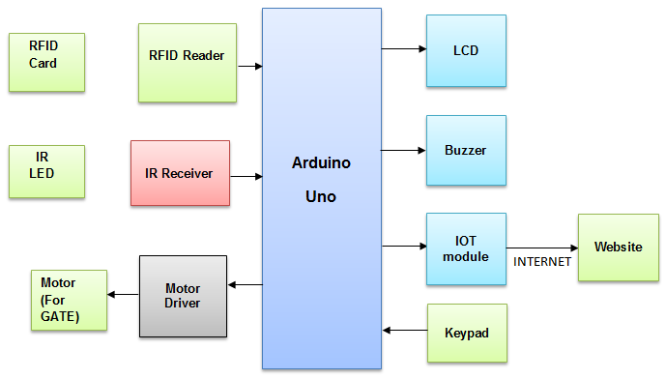

**UML Daigrams:**

CLASS DIAGRAM:

The class diagram is used to refine the use case diagram and define a detailed design of the system. The class diagram classifies the actors defined in the use case diagram into a set of interrelated classes. The relationship or association between the classes can be either an "is-a" or "has-a" relationship. Each class in the class diagram may be capable of providing certain functionalities. These functionalities provided by the class are termed "methods" of the class. Apart from this, each class may have certain "attributes" that uniquely.



Use case Diagram:

A use case diagram in the Unified Modeling Language (UML) is a type of behavioral diagram defined by and created from a Use-case analysis. Its purpose is to present a graphical overview of the functionality provided by a system in terms of actors, their goals (represented as use cases), and any dependencies between those use cases. The main purpose of a use case diagram is to show what system functions are performed for which actor. Roles of the actors in the system can be depicted.



Sequence Diagram:

A sequence diagram represents the interaction between different objects in the system. The important aspect of a sequence diagram is that it is time-ordered. This means that the exact sequence of the interactions between the objects is represented step by step. Different objects in the sequence diagram interact with each other by passing "messages".



Collaborative Diagram:



A collaboration diagram groups together the interactions between different objects. The interactions are listed as numbered interactions that help to trace the sequence of the interactions. The collaboration diagram helps to identify all the possible int

**System Environment:**

What is Python :-

Below are some facts about Python.

Python is currently the most widely used multi-purpose, high-level programming language.

Python allows programming in Object-Oriented and Procedural paradigms. Python programs generally are smaller than other programming languages like Java.

Programmers have to type relatively less and indentation requirement of the language, makes them readable all the time.

Python language is being used by almost all tech-giant companies like – Google, Amazon, Facebook, Instagram, Dropbox, Uber… etc.

The biggest strength of Python is huge collection of standard library which can be used for the following .

* + [Machine Learning](https://www.geeksforgeeks.org/machine-learning/)
  + GUI Applications (like Kivy, Tkinter, PyQt etc. )
  + Web frameworks like Django (used by YouTube, Instagram, Dropbox)
  + Image processing (like Opencv, Pillow)
  + Web scraping (like Scrapy, BeautifulSoup, Selenium)
  + Test frameworks
  + Advantages of Python :-
  + Let’s see how Python dominates over other languages.
  + **1. Extensive Libraries**
  + Python downloads with an extensive library and it *contain code for various purposes like regular expressions, documentation-generation, unit-testing, web browsers, threading, databases, CGI, email, image manipulation, and more.* So, we don’t have to write the complete code for that manually.
  + **2. Extensible**
  + As we have seen earlier, Python can be**extended to other languages**. You can write some of your code in languages like C++ or C. This comes in handy, especially in projects.
  + **3. Embeddable**
  + Complimentary to extensibility, Python is embeddable as well. You can put your Python code in your source code of a different language, like C++. This lets us add **scripting capabilities**to our code in the other language.
  + **4. Improved Productivity**
  + The language’s simplicity and extensive libraries render programmers**more productive** than languages like Java and C++ do. Also, the fact that you need to write less and get more things done.
  + **5. IOT Opportunities**
  + Since Python forms the basis of new platforms like Raspberry Pi, it finds the future bright for the Internet Of Things. This is a way to connect the language with the real world.
  + **6. Simple and Easy**
  + When working with Java, you may have to create a class to print **‘Hello World’**. But in Python, just a print statement will do. It is also quite **easy to learn, understand,** and**code.** This is why when people pick up Python, they have a hard time adjusting to other more verbose languages like Java.
  + **7. Readable**
  + Because it is not such a verbose language, reading Python is much like reading English. This is the reason why it is so easy to learn, understand, and code. It also does not need curly braces to define blocks, and **indentation is mandatory.** This further aids the readability of the code.
  + **8. Object-Oriented**
  + This language supports both the **procedural and object-oriented**programming paradigms. While functions help us with code reusability, classes and objects let us model the real world. A class allows the **encapsulation of data** and functions into one.
  + **9. Free and Open-Source**
  + Like we said earlier, Python is **freely available.** But not only can you[**download Python**](https://data-flair.training/blogs/install-python-windows/) for free, but you can also download its source code, make changes to it, and even distribute it. It downloads with an extensive collection of libraries to help you with your tasks.
  + **10. Portable**
  + When you code your project in a language like C++, you may need to make some changes to it if you want to run it on another platform. But it isn’t the same with Python. Here, you need to**code only once**, and you can run it anywhere. This is called **Write Once Run Anywhere (WORA)**. However, you need to be careful enough not to include any system-dependent features.
  + **11. Interpreted**
  + Lastly, we will say that it is an interpreted language. Since statements are executed one by one, **debugging is easier** than in compiled languages.
  + *Any doubts till now in the advantages of Python? Mention in the comment section.*
  + **Advantages of Python Over Other Languages**
  + **1. Less Coding**
  + Almost all of the tasks done in Python requires less coding when the same task is done in other languages. Python also has an awesome standard library support, so you don’t have to search for any third-party libraries to get your job done. This is the reason that many people suggest learning Python to beginners.
  + **2. Affordable**
  + Python is free therefore individuals, small companies or big organizations can leverage the free available resources to build applications. Python is popular and widely used so it gives you better community support.
  + **The 2019 Github annual survey showed us that Python has overtaken Java in the most popular programming language category.**
  + **3. Python is for Everyone**
  + Python code can run on any machine whether it is Linux, Mac or Windows. Programmers need to learn different languages for different jobs but with Python, you can professionally build web apps, perform data analysis and [**machine learning**](https://data-flair.training/blogs/machine-learning-tutorials-home/), automate things, do web scraping and also build games and powerful visualizations. It is an all-rounder programming language.
  + **Disadvantages of Python**
  + So far, we’ve seen why Python is a great choice for your project. But if you choose it, you should be aware of its consequences as well. Let’s now see the downsides of choosing Python over another language.
  + **1. Speed Limitations**
  + We have seen that Python code is executed line by line. But since [Python](https://www.python.org/) is interpreted, it often results in **slow execution**. This, however, isn’t a problem unless speed is a focal point for the project. In other words, unless high speed is a requirement, the benefits offered by Python are enough to distract us from its speed limitations.
  + **2. Weak in Mobile Computing and Browsers**
  + While it serves as an excellent server-side language, Python is much rarely seen on the **client-side**. Besides that, it is rarely ever used to implement smartphone-based applications. One such application is called **Carbonnelle**.
  + The reason it is not so famous despite the existence of Brython is that it isn’t that secure.
  + **3. Design Restrictions**
  + As you know, Python is **dynamically-typed**. This means that you don’t need to declare the type of variable while writing the code. It uses **duck-typing**. But wait, what’s that? Well, it just means that if it looks like a duck, it must be a duck. While this is easy on the programmers during coding, it can**raise run-time errors**.
  + **4. Underdeveloped Database Access Layers**
  + Compared to more widely used technologies like **JDBC (Java DataBase Connectivity)** and **ODBC (Open DataBase Connectivity)**, Python’s database access layers are a bit underdeveloped. Consequently, it is less often applied in huge enterprises.
  + **5. Simple**
  + No, we’re not kidding. Python’s simplicity can indeed be a problem. Take my example. I don’t do Java, I’m more of a Python person. To me, its syntax is so simple that the verbosity of Java code seems unnecessary.
  + This was all about the Advantages and Disadvantages of Python Programming Language.
  + **History of Python : -**
  + What do the alphabet and the programming language Python have in common? Right, both start with ABC. If we are talking about ABC in the Python context, it's clear that the programming language ABC is meant. ABC is a general-purpose programming language and programming environment, which had been developed in the Netherlands, Amsterdam, at the CWI (Centrum Wiskunde &Informatica). The greatest achievement of ABC was to influence the design of Python.Python was conceptualized in the late 1980s. Guido van Rossum worked that time in a project at the CWI, called Amoeba, a distributed operating system. In an interview with Bill Venners1, Guido van Rossum said: "In the early 1980s, I worked as an implementer on a team building a language called ABC at Centrum voor Wiskunde en Informatica (CWI).
  + I don't know how well people know ABC's influence on Python. I try to mention ABC's influence because I'm indebted to everything I learned during that project and to the people who worked on it."Later on in the same Interview, Guido van Rossum continued: "I remembered all my experience and some of my frustration with ABC. I decided to try to design a simple scripting language that possessed some of ABC's better properties, but without its problems. So I started typing. I created a simple virtual machine, a simple parser, and a simple runtime. I made my own version of the various ABC parts that I liked. I created a basic syntax, used indentation for statement grouping instead of curly braces or begin-end blocks, and developed a small number of powerful data types: a hash table (or dictionary, as we call it), a list, strings, and numbers."
  + **What is Machine Learning : -**
  + Before we take a look at the details of various machine learning methods, let's start by looking at what machine learning is, and what it isn't. Machine learning is often categorized as a subfield of artificial intelligence, but I find that categorization can often be misleading at first brush. The study of machine learning certainly arose from research in this context, but in the data science application of machine learning methods, it's more helpful to think of machine learning as a means of *building models of data*.
  + Fundamentally, machine learning involves building mathematical models to help understand data. "Learning" enters the fray when we give these models *tunable parameters* that can be adapted to observed data; in this way the program can be considered to be "learning" from the data.
  + Once these models have been fit to previously seen data, they can be used to predict and understand aspects of newly observed data. I'll leave to the reader the more philosophical digression regarding the extent to which this type of mathematical, model-based "learning" is similar to the "learning" exhibited by the human brain.Understanding the problem setting in machine learning is essential to using these tools effectively, and so we will start with some broad categorizations of the types of approaches we'll discuss here.
  + **Categories Of Machine Leaning :-**
  + At the most fundamental level, machine learning can be categorized into two main types: supervised learning and unsupervised learning.
  + *Supervised learning* involves somehow modeling the relationship between measured features of data and some label associated with the data; once this model is determined, it can be used to apply labels to new, unknown data. This is further subdivided into *classification* tasks and *regression* tasks: in classification, the labels are discrete categories, while in regression, the labels are continuous quantities. We will see examples of both types of supervised learning in the following section.
  + *Unsupervised learning* involves modeling the features of a dataset without reference to any label, and is often described as "letting the dataset speak for itself." These models include tasks such as *clustering* and *dimensionality reduction.*
  + Clustering algorithms identify distinct groups of data, while dimensionality reduction algorithms search for more succinct representations of the data. We will see examples of both types of unsupervised learning in the following section.
  + **Need for Machine Learning**
  + Human beings, at this moment, are the most intelligent and advanced species on earth because they can think, evaluate and solve complex problems. On the other side, AI is still in its initial stage and haven’t surpassed human intelligence in many aspects. Then the question is that what is the need to make machine learn? The most suitable reason for doing this is, “to make decisions, based on data, with efficiency and scale”.
  + Lately, organizations are investing heavily in newer technologies like Artificial Intelligence, Machine Learning and Deep Learning to get the key information from data to perform several real-world tasks and solve problems. We can call it data-driven decisions taken by machines, particularly to automate the process. These data-driven decisions can be used, instead of using programing logic, in the problems that cannot be programmed inherently. The fact is that we can’t do without human intelligence, but other aspect is that we all need to solve real-world problems with efficiency at a huge scale. That is why the need for machine learning arises.
  + **Challenges in Machines Learning :**
  + While Machine Learning is rapidly evolving, making significant strides with cybersecurity and autonomous cars, this segment of AI as whole still has a long way to go. The reason behind is that ML has not been able to overcome number of challenges. The challenges that ML is facing currently are −
  + **Quality of data** − Having good-quality data for ML algorithms is one of the biggest challenges. Use of low-quality data leads to the problems related to data preprocessing and feature extraction.
  + **Time-Consuming task** − Another challenge faced by ML models is the consumption of time especially for data acquisition, feature extraction and retrieval.
  + **Lack of specialist persons** − As ML technology is still in its infancy stage, availability of expert resources is a tough job.
  + **No clear objective for formulating business problems** − Having no clear objective and well-defined goal for business problems is another key challenge for ML because this technology is not that mature yet.
  + **Issue of overfitting & underfitting** − If the model is overfitting or underfitting, it cannot be represented well for the problem.
  + **Curse of dimensionality** − Another challenge ML model faces is too many features of data points. This can be a real hindrance.
  + **Difficulty in deployment** − Complexity of the ML model makes it quite difficult to be deployed in real life.
  + **Applications of Machines Learning :-**
  + Machine Learning is the most rapidly growing technology and according to researchers we are in the golden year of AI and ML. It is used to solve many real-world complex problems which cannot be solved with traditional approach. Following are some real-world applications of ML −
  + Emotion analysis
  + Sentiment analysis
  + Error detection and prevention
  + Weather forecasting and prediction
  + Stock market analysis and forecasting
  + Speech synthesis
  + Speech recognition
  + Customer segmentation
  + Object recognition
  + Fraud detection
  + Fraud prevention
  + Recommendation of products to customer in online shopping
  + **How to Start Learning Machine Learning?**
  + Arthur Samuel coined the term **“Machine Learning”** in 1959 and defined it as a **“Field of study that gives computers the capability to learn without being explicitly programmed”.**
  + And that was the beginning of Machine Learning! In modern times, Machine Learning is one of the most popular (if not the most!) career choices. According to [Indeed](http://blog.indeed.com/2019/03/14/best-jobs-2019/), Machine Learning Engineer Is The Best Job of 2019 with a *344%* growth and an average base salary of **$146,085** per year.
  + But there is still a lot of doubt about what exactly is Machine Learning and how to start learning it? So this article deals with the Basics of Machine Learning and also the path you can follow to eventually become a full-fledged Machine Learning Engineer. Now let’s get started!!!
  + **How to start learning ML?**
  + This is a rough roadmap you can follow on your way to becoming an insanely talented Machine Learning Engineer. Of course, you can always modify the steps according to your needs to reach your desired end-goal!
  + Step 1 – Understand the Prerequisites
  + In case you are a genius, you could start ML directly but normally, there are some prerequisites that you need to know which include Linear Algebra, Multivariate Calculus, Statistics, and Python. And if you don’t know these, never fear! You don’t need a Ph.D. degree in these topics to get started but you do need a basic understanding.
  + **(a) Learn Linear Algebra and Multivariate Calculus**
  + Both Linear Algebra and Multivariate Calculus are important in Machine Learning. However, the extent to which you need them depends on your role as a data scientist. If you are more focused on application heavy machine learning, then you will not be that heavily focused on maths as there are many common libraries available. But if you want to focus on R&D in Machine Learning, then mastery of Linear Algebra and Multivariate Calculus is very important as you will have to implement many ML algorithms from scratch.
  + **(b) Learn Statistics**
  + Data plays a huge role in Machine Learning. In fact, around 80% of your time as an ML expert will be spent collecting and cleaning data. And statistics is a field that handles the collection, analysis, and presentation of data. So it is no surprise that you need to learn it!!!  
    Some of the key concepts in statistics that are important are Statistical Significance, Probability Distributions, Hypothesis Testing, Regression, etc. Also, Bayesian Thinking is also a very important part of ML which deals with various concepts like Conditional Probability, Priors, and Posteriors, Maximum Likelihood, etc.
  + **(c) Learn Python**
  + Some people prefer to skip Linear Algebra, Multivariate Calculus and Statistics and learn them as they go along with trial and error. But the one thing that you absolutely cannot skip is [Python](https://www.geeksforgeeks.org/python-programming-language/)! While there are other languages you can use for Machine Learning like R, Scala, etc. Python is currently the most popular language for ML. In fact, there are many Python libraries that are specifically useful for Artificial Intelligence and Machine Learning such as [Keras](https://keras.io/), [TensorFlow](https://www.tensorflow.org/), [Scikit-learn](https://scikit-learn.org/stable/), etc.
  + So if you want to learn ML, it’s best if you learn Python! You can do that using various online resources and courses such as [**Fork Python**](https://practice.geeksforgeeks.org/courses/fork-python) available Free on GeeksforGeeks.
  + **Step 2 – Learn Various ML Concepts**
  + Now that you are done with the prerequisites, you can move on to actually learning ML (Which is the fun part!!!) It’s best to start with the basics and then move on to the more complicated stuff. Some of the basic concepts in ML are:
  + **(a) Terminologies of Machine Learning**
  + **Model –**A model is a specific representation learned from data by applying some machine learning algorithm. A model is also called a hypothesis.
  + **Feature –**A feature is an individual measurable property of the data. A set of numeric features can be conveniently described by a feature vector. Feature vectors are fed as input to the model. For example, in order to predict a fruit, there may be features like color, smell, taste, etc.
  + **Target (Label) –**A target variable or label is the value to be predicted by our model. For the fruit example discussed in the feature section, the label with each set of input would be the name of the fruit like apple, orange, banana, etc.
  + **Training –**The idea is to give a set of inputs(features) and it’s expected outputs(labels), so after training, we will have a model (hypothesis) that will then map new data to one of the categories trained on.
  + **Prediction –**Once our model is ready, it can be fed a set of inputs to which it will provide a predicted output(label).
  + **(b) Types of Machine Learning**
  + **Supervised Learning –**This involves learning from a training dataset with labeled data using classification and regression models. This learning process continues until the required level of performance is achieved.
  + **Unsupervised Learning –**This involves using unlabeled data and then finding the underlying structure in the data in order to learn more and more about the data itself using factor and cluster analysis models.
  + **Semi-supervised Learning –**This involves using unlabeled data like Unsupervised Learning with a small amount of labeled data. Using labeled data vastly increases the learning accuracy and is also more cost-effective than Supervised Learning.
  + **Reinforcement Learning –**This involves learning optimal actions through trial and error. So the next action is decided by learning behaviors that are based on the current state and that will maximize the reward in the future.
  + **Advantages of Machine learning :-**
  + **1. Easily identifies trends and patterns -**
  + Machine Learning can review large volumes of data and discover specific trends and patterns that would not be apparent to humans. For instance, for an e-commerce website like Amazon, it serves to understand the browsing behaviors and purchase histories of its users to help cater to the right products, deals, and reminders relevant to them. It uses the results to reveal relevant advertisements to them.
  + **2. No human intervention needed (automation)**
  + With ML, you don’t need to babysit your project every step of the way. Since it means giving machines the ability to learn, it lets them make predictions and also improve the algorithms on their own. A common example of this is anti-virus softwares; they learn to filter new threats as they are recognized. ML is also good at recognizing spam.
  + **3. Continuous Improvement**
  + As [**ML algorithms**](https://data-flair.training/blogs/machine-learning-algorithms/) gain experience, they keep improving in accuracy and efficiency. This lets them make better decisions. Say you need to make a weather forecast model. As the amount of data you have keeps growing, your algorithms learn to make more accurate predictions faster.
  + **4. Handling multi-dimensional and multi-variety data**
  + Machine Learning algorithms are good at handling data that are multi-dimensional and multi-variety, and they can do this in dynamic or uncertain environments.
  + **5. Wide Applications**
  + You could be an e-tailer or a healthcare provider and make ML work for you. Where it does apply, it holds the capability to help deliver a much more personal experience to customers while also targeting the right customers.
  + **Disadvantages of Machine Learning :-**
  + **1. Data Acquisition**
  + Machine Learning requires massive data sets to train on, and these should be inclusive/unbiased, and of good quality. There can also be times where they must wait for new data to be generated.
  + **2. Time and Resources**
  + ML needs enough time to let the algorithms learn and develop enough to fulfill their purpose with a considerable amount of accuracy and relevancy. It also needs massive resources to function. This can mean additional requirements of computer power for you.
  + **3. Interpretation of Results**
  + Another major challenge is the ability to accurately interpret results generated by the algorithms. You must also carefully choose the algorithms for your purpose.
  + **4. High error-susceptibility**
  + [Machine Learning](https://en.wikipedia.org/wiki/Machine_learning) is autonomous but highly susceptible to errors. Suppose you train an algorithm with data sets small enough to not be inclusive. You end up with biased predictions coming from a biased training set. This leads to irrelevant advertisements being displayed to customers. In the case of ML, such blunders can set off a chain of errors that can go undetected for long periods of time. And when they do get noticed, it takes quite some time to recognize the source of the issue, and even longer to correct it.
  + **Python Development Steps : -**
  + Guido Van Rossum published the first version of Python code (version 0.9.0) at alt.sources in February 1991. This release included already exception handling, functions, and the core data types of list, dict, str and others. It was also object oriented and had a module system.  
    Python version 1.0 was released in January 1994. The major new features included in this release were the functional programming tools lambda, map, filter and reduce, which Guido Van Rossum never liked.Six and a half years later in October 2000, Python 2.0 was introduced. This release included list comprehensions, a full garbage collector and it was supporting unicode.Python flourished for another 8 years in the versions 2.x before the next major release as Python 3.0 (also known as "Python 3000" and "Py3K") was released. Python 3 is not backwards compatible with Python 2.x.
  + The emphasis in Python 3 had been on the removal of duplicate programming constructs and modules, thus fulfilling or coming close to fulfilling the 13th law of the Zen of Python: "There should be one -- and preferably only one -- obvious way to do it."Some changes in Python 7.3:
  + Print is now a function
  + Views and iterators instead of lists
  + The rules for ordering comparisons have been simplified. E.g. a heterogeneous list cannot be sorted, because all the elements of a list must be comparable to each other.
  + There is only one integer type left, i.e. int. long is int as well.
  + The division of two integers returns a float instead of an integer. "//" can be used to have the "old" behaviour.
  + Text Vs. Data Instead Of Unicode Vs. 8-bit
  + **Purpose :-**
  + We demonstrated that our approach enables successful segmentation of intra-retinal layers—even with low-quality images containing speckle noise, low contrast, and different intensity ranges throughout—with the assistance of the ANIS feature.
  + **Python**
  + Python is an interpreted high-level programming language for general-purpose programming. Created by Guido van Rossum and first released in 1991, Python has a design philosophy that emphasizes code readability, notably using significant whitespace.
  + Python features a dynamic type system and automatic memory management. It supports multiple programming paradigms, including object-oriented, imperative, functional and procedural, and has a large and comprehensive standard library.
  + Python is Interpreted − Python is processed at runtime by the interpreter. You do not need to compile your program before executing it. This is similar to PERL and PHP.
  + Python is Interactive − you can actually sit at a Python prompt and interact with the interpreter directly to write your programs.
  + Python also acknowledges that speed of development is important. Readable and terse code is part of this, and so is access to powerful constructs that avoid tedious repetition of code. Maintainability also ties into this may be an all but useless metric, but it does say something about how much code you have to scan, read and/or understand to troubleshoot problems or tweak behaviors. This speed of development, the ease with which a programmer of other languages can pick up basic Python skills and the huge standard library is key to another area where Python excels. All its tools have been quick to implement, saved a lot of time, and several of them have later been patched and updated by people with no Python background - without breaking.
  + **Modules Used in Project :-**
  + **Tensorflow**
  + TensorFlow is a [free](https://en.wikipedia.org/wiki/Free_software) and [open-source](https://en.wikipedia.org/wiki/Open-source_software) [software library for dataflow and differentiable programming](https://en.wikipedia.org/wiki/Library_(computing)) across a range of tasks. It is a symbolic math library, and is also used for [machine learning](https://en.wikipedia.org/wiki/Machine_learning) applications such as [neural networks](https://en.wikipedia.org/wiki/Neural_networks). It is used for both research and production at [Google](https://en.wikipedia.org/wiki/Google).‍
  + TensorFlow was developed by the [Google Brain](https://en.wikipedia.org/wiki/Google_Brain) team for internal Google use. It was released under the [Apache 2.0](https://en.wikipedia.org/wiki/Apache_License) [open-source license](https://en.wikipedia.org/wiki/Open-source_license) on November 9, 2015.
  + **Numpy**
  + Numpy is a general-purpose array-processing package. It provides a high-performance multidimensional array object, and tools for working with these arrays.
  + It is the fundamental package for scientific computing with Python. It contains various features including these important ones:
  + A powerful N-dimensional array object
  + Sophisticated (broadcasting) functions
  + Tools for integrating C/C++ and Fortran code
  + Useful linear algebra, Fourier transform, and random number capabilities
  + Besides its obvious scientific uses, Numpy can also be used as an efficient multi-dimensional container of generic data. Arbitrary data-types can be defined using Numpy which allows Numpy to seamlessly and speedily integrate with a wide variety of databases.
  + **Pandas**
  + Pandas is an open-source Python Library providing high-performance data manipulation and analysis tool using its powerful data structures. Python was majorly used for data munging and preparation. It had very little contribution towards data analysis. Pandas solved this problem. Using Pandas, we can accomplish five typical steps in the processing and analysis of data, regardless of the origin of data load, prepare, manipulate, model, and analyze. Python with Pandas is used in a wide range of fields including academic and commercial domains including finance, economics, Statistics, analytics, etc.
  + **Matplotlib**
  + Matplotlib is a Python 2D plotting library which produces publication quality figures in a variety of hardcopy formats and interactive environments across platforms. Matplotlib can be used in Python scripts, the Python and [IPython](http://ipython.org/) shells, the [Jupyter](http://jupyter.org/) Notebook, web application servers, and four graphical user interface toolkits. Matplotlib tries to make easy things easy and hard things possible. You can generate plots, histograms, power spectra, bar charts, error charts, scatter plots, etc., with just a few lines of code. For examples, see the [sample plots](https://matplotlib.org/tutorials/introductory/sample_plots.html) and [thumbnail gallery](https://matplotlib.org/gallery/index.html).
  + For simple plotting the pyplot module provides a MATLAB-like interface, particularly when combined with IPython. For the power user, you have full control of line styles, font properties, axes properties, etc, via an object oriented interface or via a set of functions familiar to MATLAB users.
  + **Scikit – learn**
  + Scikit-learn provides a range of supervised and unsupervised learning algorithms via a consistent interface in Python. It is licensed under a permissive simplified BSD license and is distributed under many Linux distributions, encouraging academic and commercial use. **Python**
  + Python is an interpreted high-level programming language for general-purpose programming. Created by Guido van Rossum and first released in 1991, Python has a design philosophy that emphasizes code readability, notably using significant whitespace.
  + Python features a dynamic type system and automatic memory management. It supports multiple programming paradigms, including object-oriented, imperative, functional and procedural, and has a large and comprehensive standard library.
  + Python is Interpreted − Python is processed at runtime by the interpreter. You do not need to compile your program before executing it. This is similar to PERL and PHP.
  + Python is Interactive − you can actually sit at a Python prompt and interact with the interpreter directly to write your programs.
  + Python also acknowledges that speed of development is important. Readable and terse code is part of this, and so is access to powerful constructs that avoid tedious repetition of code. Maintainability also ties into this may be an all but useless metric, but it does say something about how much code you have to scan, read and/or understand to troubleshoot problems or tweak behaviors. This speed of development, the ease with which a programmer of other languages can pick up basic Python skills and the huge standard library is key to another area where Python excels.
  + All its tools have been quick to implement, saved a lot of time, and several of them have later been patched and updated by people with no Python background - without breaking.
  + **Install Python Step-by-Step in Windows and Mac :**
  + Python a versatile programming language doesn’t come pre-installed on your computer devices. Python was first released in the year 1991 and until today it is a very popular high-level programming language. Its style philosophy emphasizes code readability with its notable use of great whitespace.
  + The object-oriented approach and language construct provided by Python enables programmers to write both clear and logical code for projects. This software does not come pre-packaged with Windows.
  + **How to Install Python on Windows and Mac**
  + There have been several updates in the Python version over the years. The question is how to install Python? It might be confusing for the beginner who is willing to start learning Python but this tutorial will solve your query. The latest or the newest version of Python is version 3.7.4 or in other words, it is Python 3.
  + **Note:** The python version 3.7.4 cannot be used on Windows XP or earlier devices.
  + Before you start with the installation process of Python. First, you need to know about your **System Requirements**. Based on your system type i.e. operating system and based processor, you must download the python version. My system type is a **Windows 64-bit operating system**. So the steps below are to install python version 3.7.4 on Windows 7 device or to install Python 3. [Download the Python Cheatsheet here.](https://myelearninghub.com/python-cheat-sheet/)The steps on how to install Python on Windows 10, 8 and 7 are **divided into 4 parts** to help understand better.
  + Download the Correct version into the system
  + **Step 1:** Go to the official site to download and install python using Google Chrome or any other web browser. OR Click on the following link: [https://www.python.org](https://www.python.org/)



* + Now, check for the latest and the correct version for your operating system.
  + **Step 2:** Click on the Download Tab.



* + **Step 3:** You can either select the Download Python for windows 3.7.4 button in Yellow Color or you can scroll further down and click on download with respective to their version. Here, we are downloading the most recent python version for windows 3.7.4



* + **Step 4:** Scroll down the page until you find the Files option.
  + **Step 5:** Here you see a different version of python along with the operating system.



* + To download Windows 32-bit python, you can select any one from the three options: Windows x86 embeddable zip file, Windows x86 executable installer or Windows x86 web-based installer.
  + To download Windows 64-bit python, you can select any one from the three options: Windows x86-64 embeddable zip file, Windows x86-64 executable installer or Windows x86-64 web-based installer.
  + Here we will install Windows x86-64 web-based installer. Here your first part regarding which version of python is to be downloaded is completed. Now we move ahead with the second part in installing python i.e. Installation
  + **Note:** To know the changes or updates that are made in the version you can click on the Release Note Option.
  + Installation of Python
  + **Step 1:** Go to Download and Open the downloaded python version to carry out the installation process.



* + **Step 2:** Before you click on Install Now, Make sure to put a tick on Add Python 3.7 to PATH.



* + **Step 3:** Click on Install NOW After the installation is successful. Click on Close.



* + With these above three steps on python installation, you have successfully and correctly installed Python. Now is the time to verify the installation.
  + **Note:** The installation process might take a couple of minutes.
  + Verify the Python Installation
  + **Step 1:** Click on Start
  + **Step 2:** In the Windows Run Command, type “cmd”.



* + **Step 3:** Open the Command prompt option.
  + **Step 4:** Let us test whether the python is correctly installed. Type **python –V** and press Enter.



* + **Step 5:** You will get the answer as 3.7.4
  + **Note:** If you have any of the earlier versions of Python already installed. You must first uninstall the earlier version and then install the new one.
  + Check how the Python IDLE works
  + **Step 1:** Click on Start
  + **Step 2:** In the Windows Run command, type “python idle”.



* + **Step 3:** Click on IDLE (Python 3.7 64-bit) and launch the program
  + **Step 4:** To go ahead with working in IDLE you must first save the file. **Click on File > Click on Save**



* + **Step 5:** Name the file and save as type should be Python files. Click on SAVE. Here I have named the files as Hey World.
  + **Step 6:** Now for e.g. **enter print**
  + **6.SYSTEM TEST**
  + The purpose of testing is to discover errors. Testing is the process of trying to discover every conceivable fault or weakness in a work product. It provides a way to check the functionality of components, sub assemblies, assemblies and/or a finished product It is the process of exercising software with the intent of ensuring that the Software system meets its requirements and user expectations and does not fail in an unacceptable manner. There are various types of test. Each test type addresses a specific testing requirement.
  + **TYPES OF TESTS**
  + **Unit testing**
  + Unit testing involves the design of test cases that validate that the internal program logic is functioning properly, and that program inputs produce valid outputs. All decision branches and internal code flow should be validated. It is the testing of individual software units of the application .it is done after the completion of an individual unit before integration. This is a structural testing, that relies on knowledge of its construction and is invasive. Unit tests perform basic tests at component level and test a specific business process, application, and/or system configuration. Unit tests ensure that each unique path of a business process performs accurately to the documented specifications and contains clearly defined inputs and expected results.
  + **Integration testing**
  + Integration tests are designed to test integrated software components to determine if they actually run as one program. Testing is event driven and is more concerned with the basic outcome of screens or fields. Integration tests demonstrate that although the components were individually satisfaction, as shown by successfully unit testing, the combination of components is correct and consistent. Integration testing is specifically aimed at exposing the problems that arise from the combination of components.
  + **Functional test**
  + Functional tests provide systematic demonstrations that functions tested are available as specified by the business and technical requirements, system documentation, and user manuals.
  + Functional testing is centered on the following items:
  + Valid Input : identified classes of valid input must be accepted.
  + Invalid Input : identified classes of invalid input must be rejected.
  + Functions : identified functions must be exercised.
  + Output : identified classes of application outputs must be exercised.
  + Systems/Procedures : interfacing systems or procedures must be invoked.
  + Organization and preparation of functional tests is focused on requirements, key functions, or special test cases. In addition, systematic coverage pertaining to identify Business process flows; data fields, predefined processes, and successive processes must be considered for testing. Before functional testing is complete, additional tests are identified and the effective value of current tests is determined.
  + **System Test**
  + System testing ensures that the entire integrated software system meets requirements. It tests a configuration to ensure known and predictable results. An example of system testing is the configuration oriented system integration test. System testing is based on process descriptions and flows, emphasizing pre-driven process links and integration points.
  + **White Box Testing**
  + White Box Testing is a testing in which in which the software tester has knowledge of the inner workings, structure and language of the software, or at least its purpose. It is purpose. It is used to test areas that cannot be reached from a black box level.
  + **Black Box Testing**
  + Black Box Testing is testing the software without any knowledge of the inner workings, structure or language of the module being tested. Black box tests, as most other kinds of tests, must be written from a definitive source document, such as specification or requirements document, such as specification or requirements document. It is a testing in which the software under test is treated, as a black box .you cannot “see” into it. The test provides inputs and responds to outputs without considering how the software works.
  + **Unit Testing**
  + Unit testing is usually conducted as part of a combined code and unit test phase of the software lifecycle, although it is not uncommon for coding and unit testing to be conducted as two distinct phases.
  + **Test strategy and approach**
  + Field testing will be performed manually and functional tests will be written in detail.
  + **Test objectives**
  + All field entries must work properly.
  + Pages must be activated from the identified link.
  + The entry screen, messages and responses must not be delayed.
  + **Features to be tested**
  + Verify that the entries are of the correct format
  + No duplicate entries should be allowed
  + All links should take the user to the correct page.
  + **Integration Testing**
  + Software integration testing is the incremental integration testing of two or more integrated software components on a single platform to produce failures caused by interface defects.
  + The task of the integration test is to check that components or software applications, e.g. components in a software system or – one step up – software applications at the company level – interact without error.
  + **Test Results:** All the test cases mentioned above passed successfully. No defects encountered.
  + **Acceptance Testing**
  + User Acceptance Testing is a critical phase of any project and requires significant participation by the end user. It also ensures that the system meets the functional requirements.
  + **Test Results:** All the test cases mentioned above passed successfully. No defects encountered.
  + **Test cases1:**
  + **Test case for Login form:**

|  |  |
| --- | --- |
| * + **FUNCTION:** | * + **LOGIN** |
| * + **EXPECTED RESULTS:** | * + Should Validate the user and check his existence in database |
| * + **ACTUAL RESULTS:** | * + Validate the user and checking the user against the database |
| * + **LOW PRIORITY** | * + **No** |
| * + **HIGH PRIORITY** | * + **Yes** |

* + **Test case2:**
  + **Test case for User Registration form:**

|  |  |
| --- | --- |
| * + **FUNCTION:** | * + **USER REGISTRATION** |
| * + **EXPECTED RESULTS:** | * + Should check if all the fields are filled by the user and saving the user to database. |
| * + **ACTUAL RESULTS:** | * + Checking whether all the fields are field by user or not through validations and saving user. |
| * + **LOW PRIORITY** | * + **No** |
| * + **HIGH PRIORITY** | * + **Yes** |

* + **Test case3:**
  + **Test case for Change Password:**
  + When the old password does not match with the new password ,then this results in displaying an error message as “ OLD PASSWORD DOES NOT MATCH WITH THE NEW PASSWORD”.

|  |  |
| --- | --- |
| * + **FUNCTION:** | * + **Change Password** |
| * + **EXPECTED RESULTS:** | * + Should check if old password and new password fields are filled by the user and saving the user to database. |
| * + **ACTUAL RESULTS:** | * + Checking whether all the fields are field by user or not through validations and saving user. |
| * + **LOW PRIORITY** | * + **No** |
| * + **HIGH PRIORITY** | * + **Yes** |
|  |  |

**Screenshots:**

**11.Online Toll identification system:**

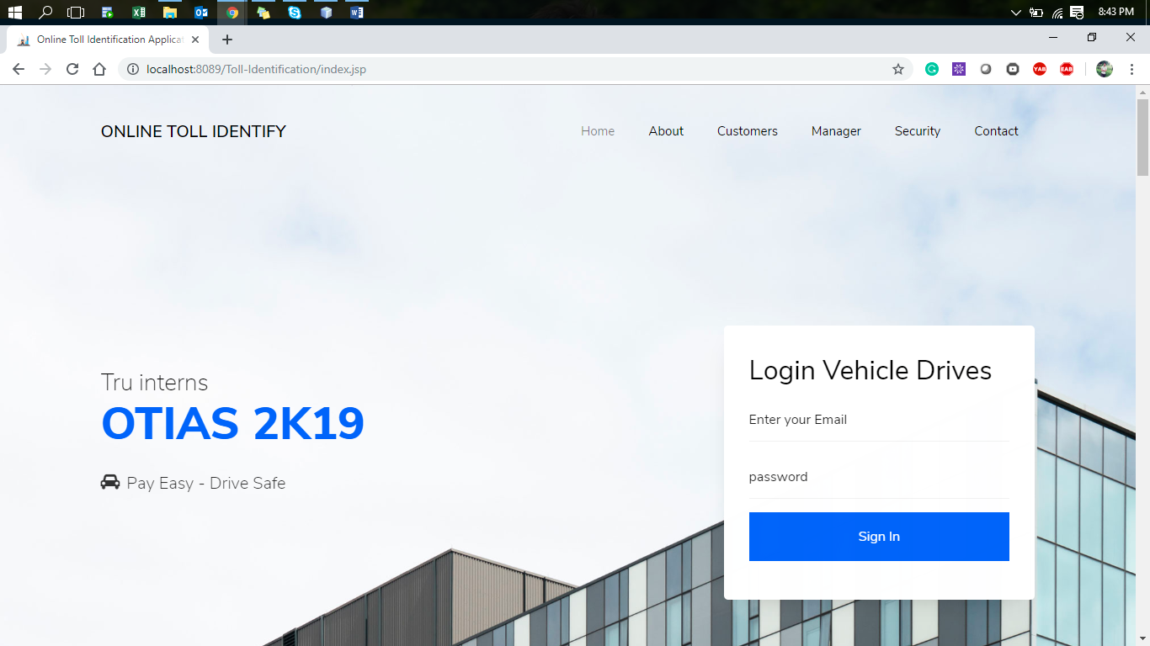

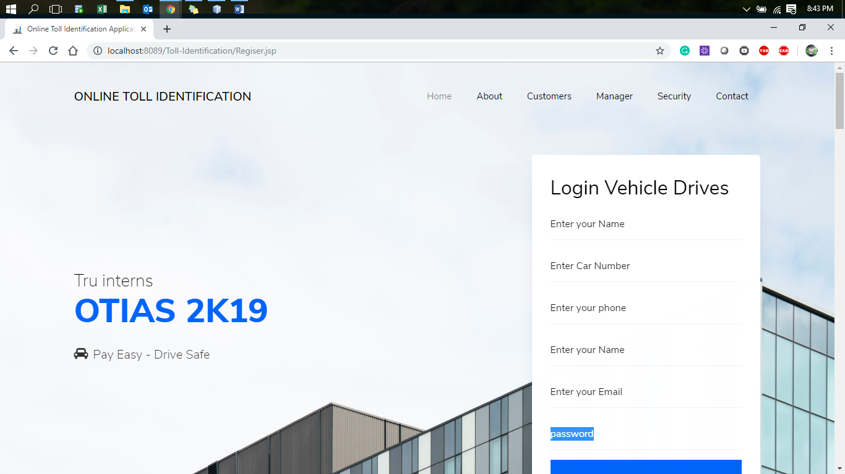

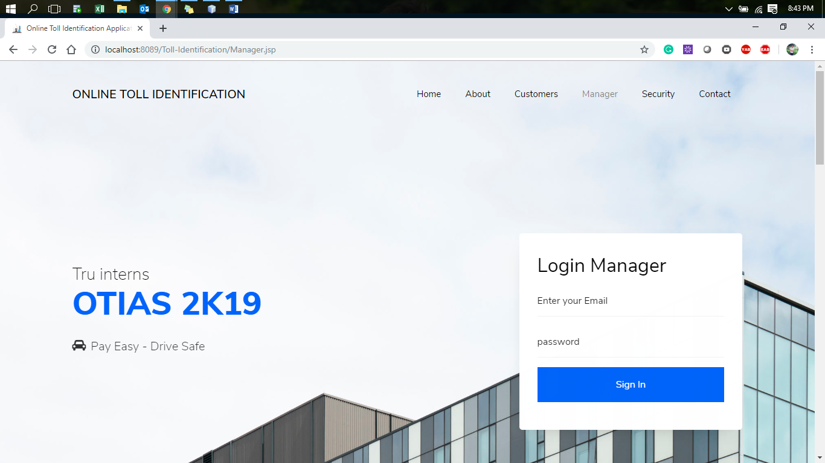

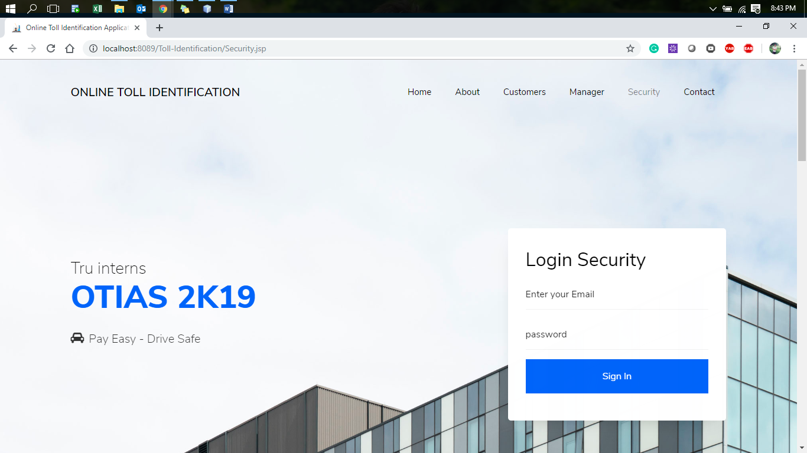



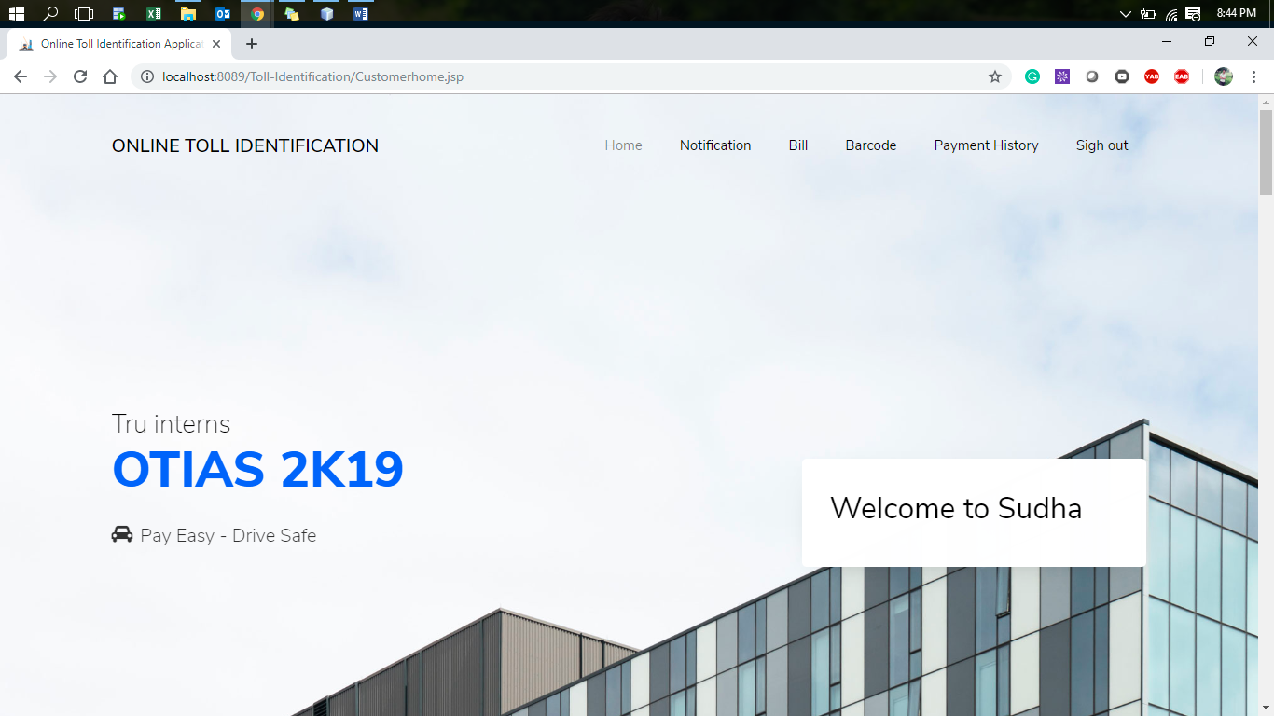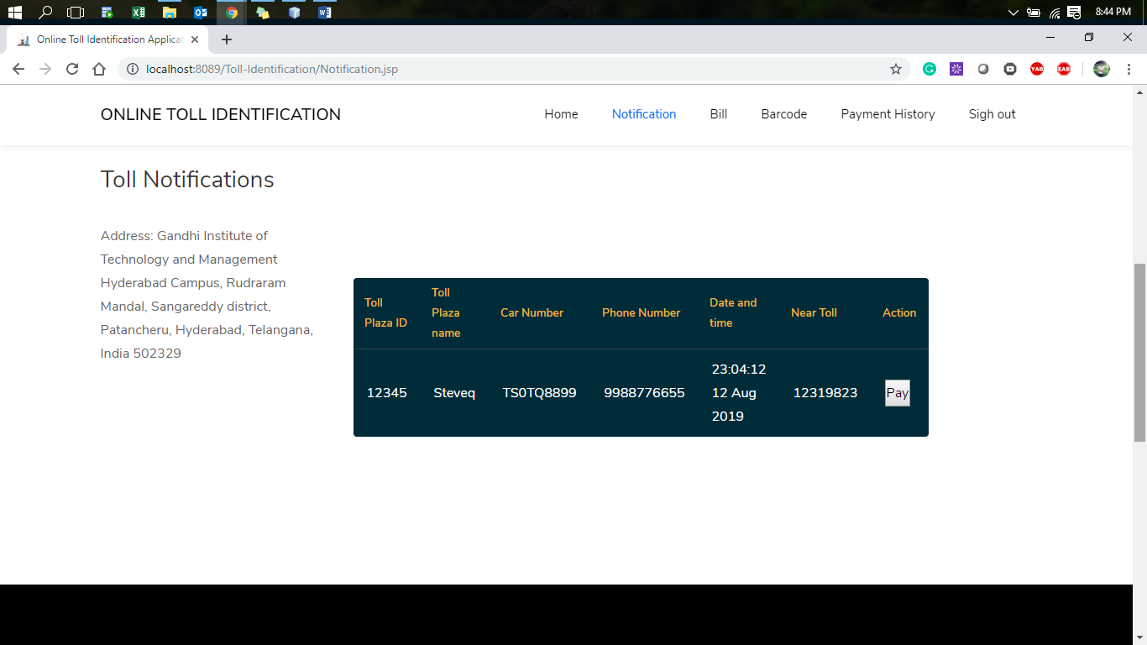

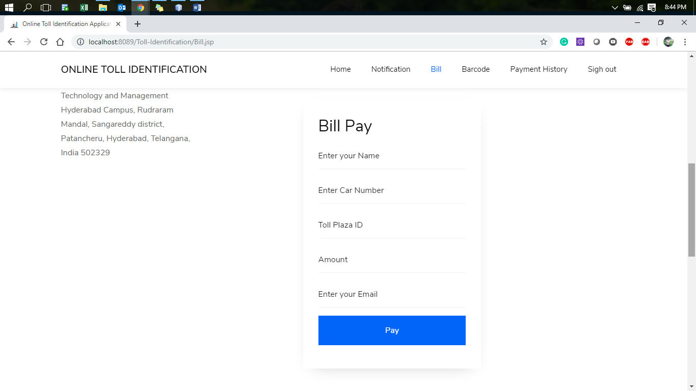

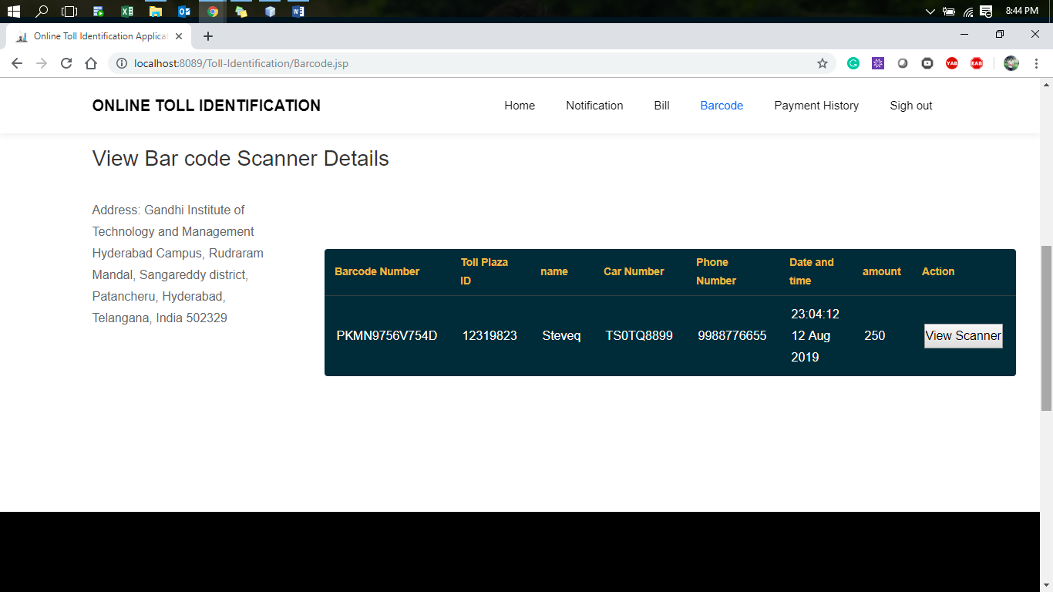

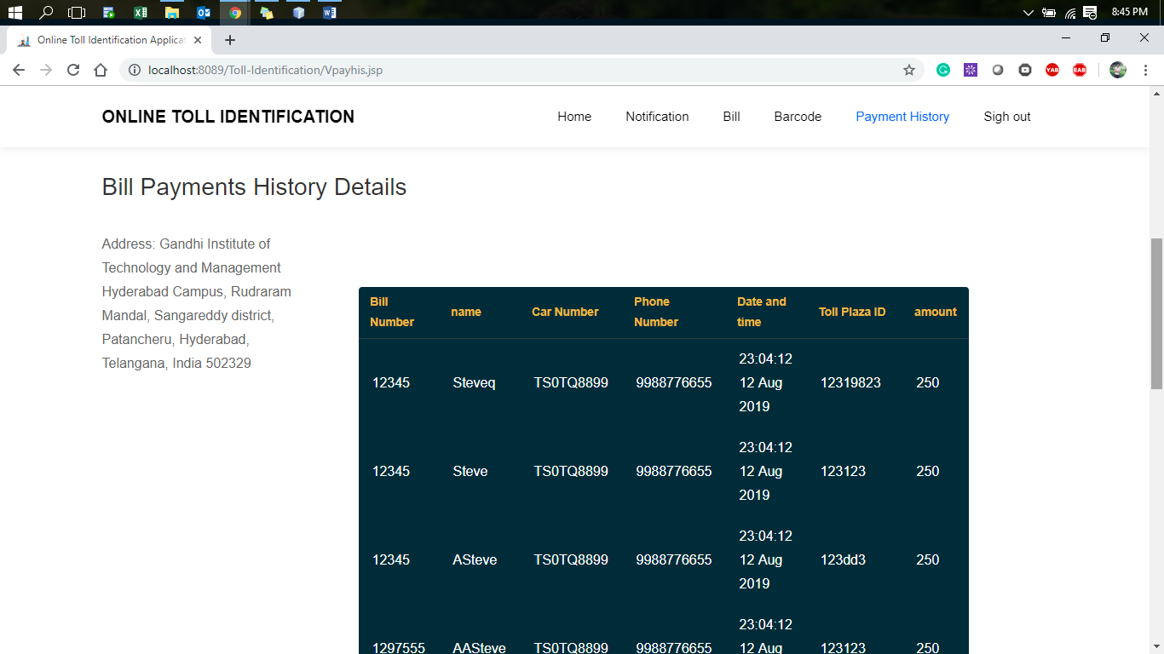

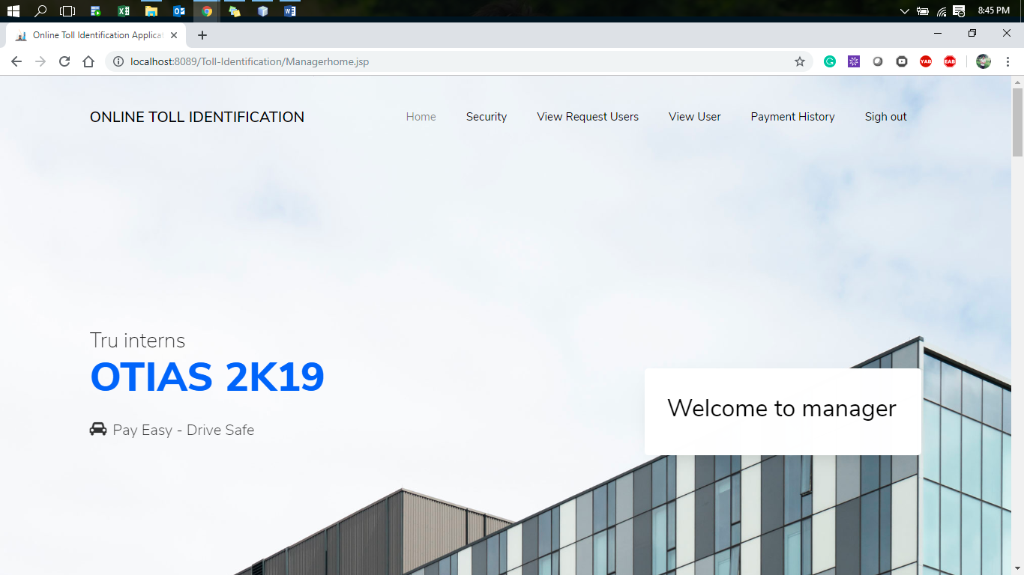

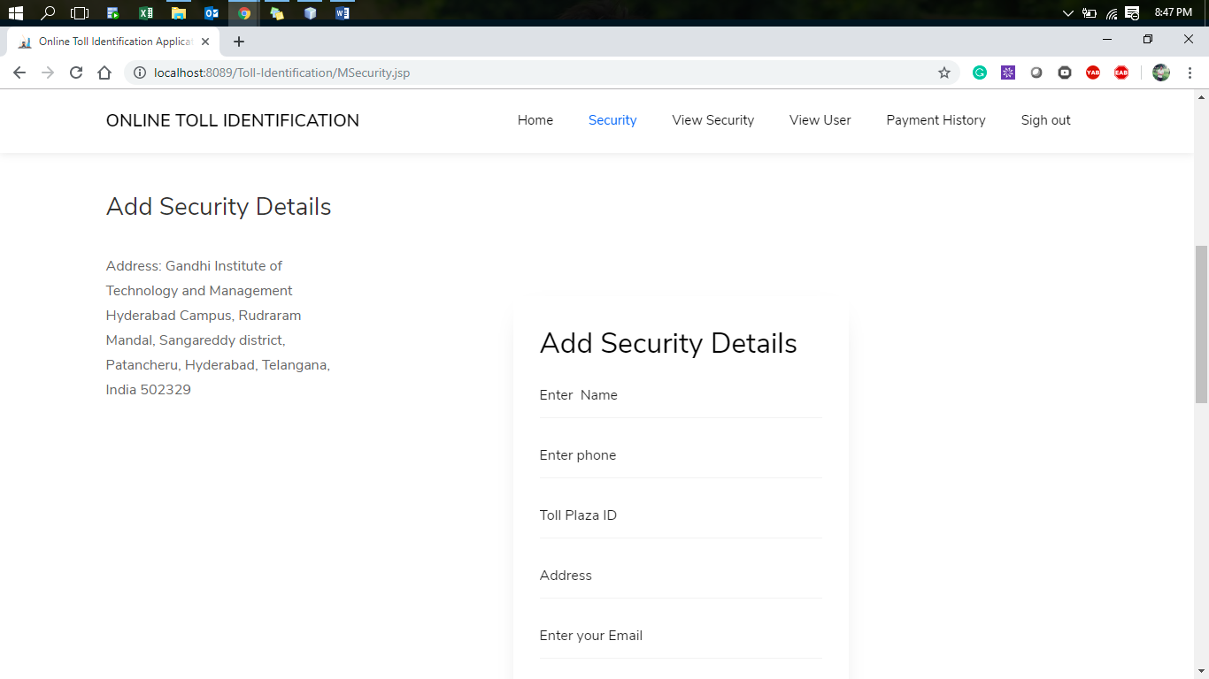

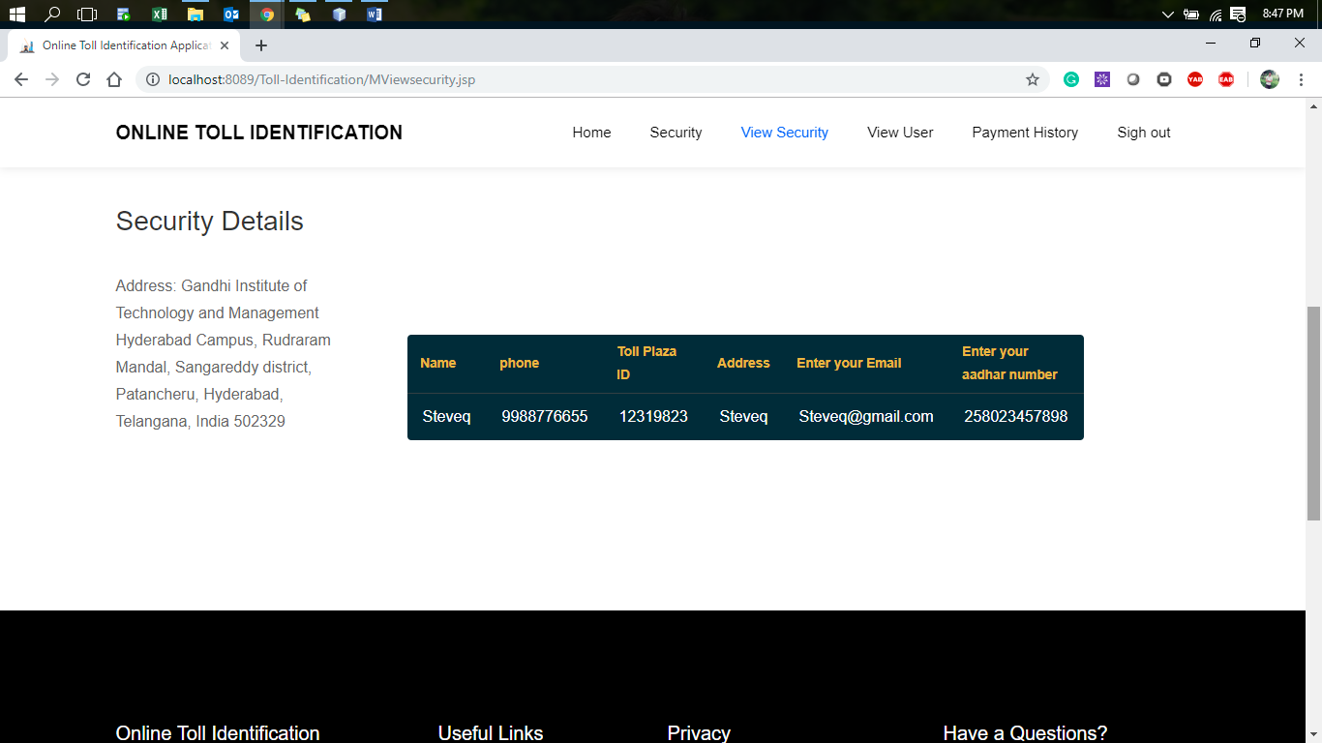

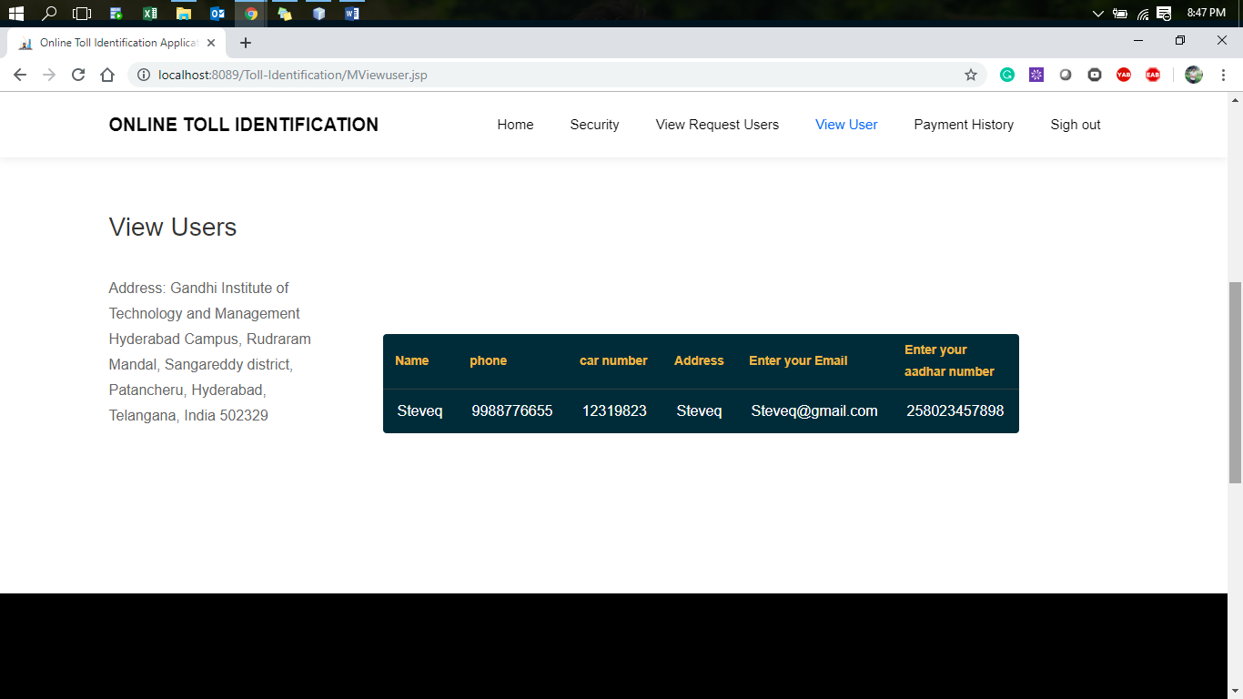

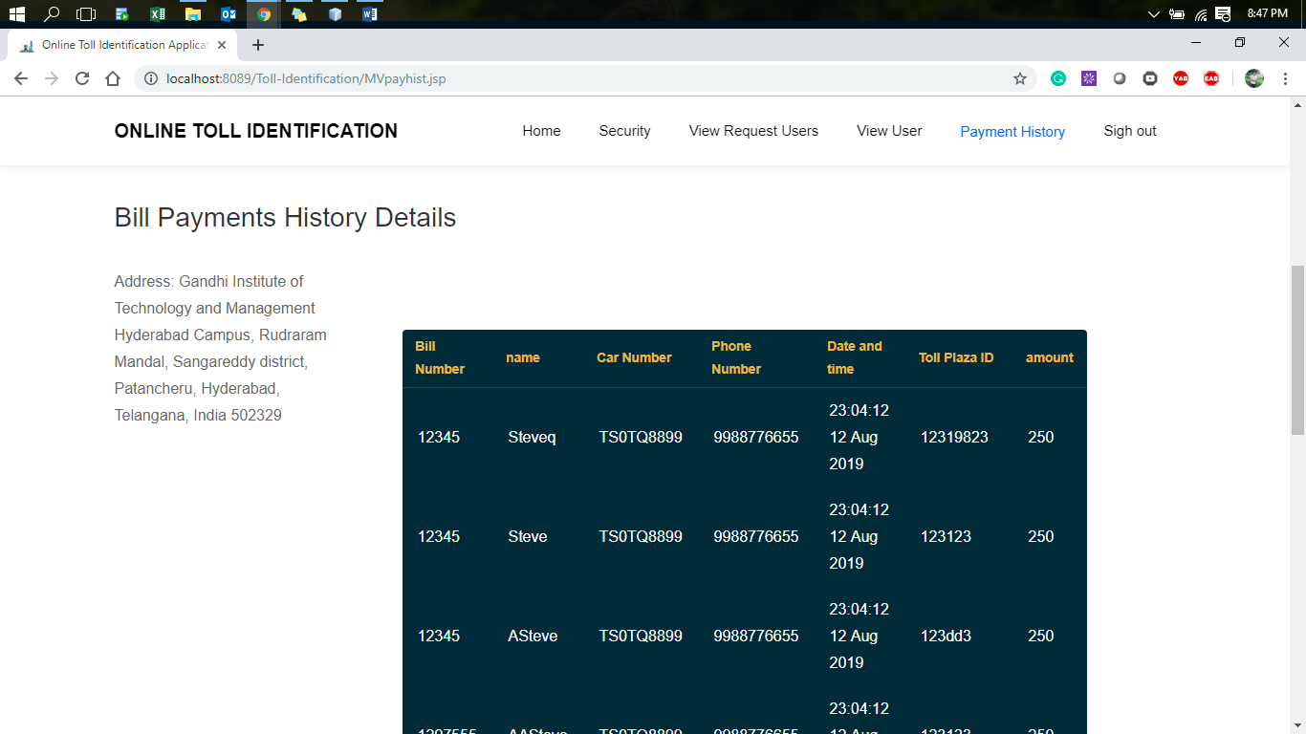

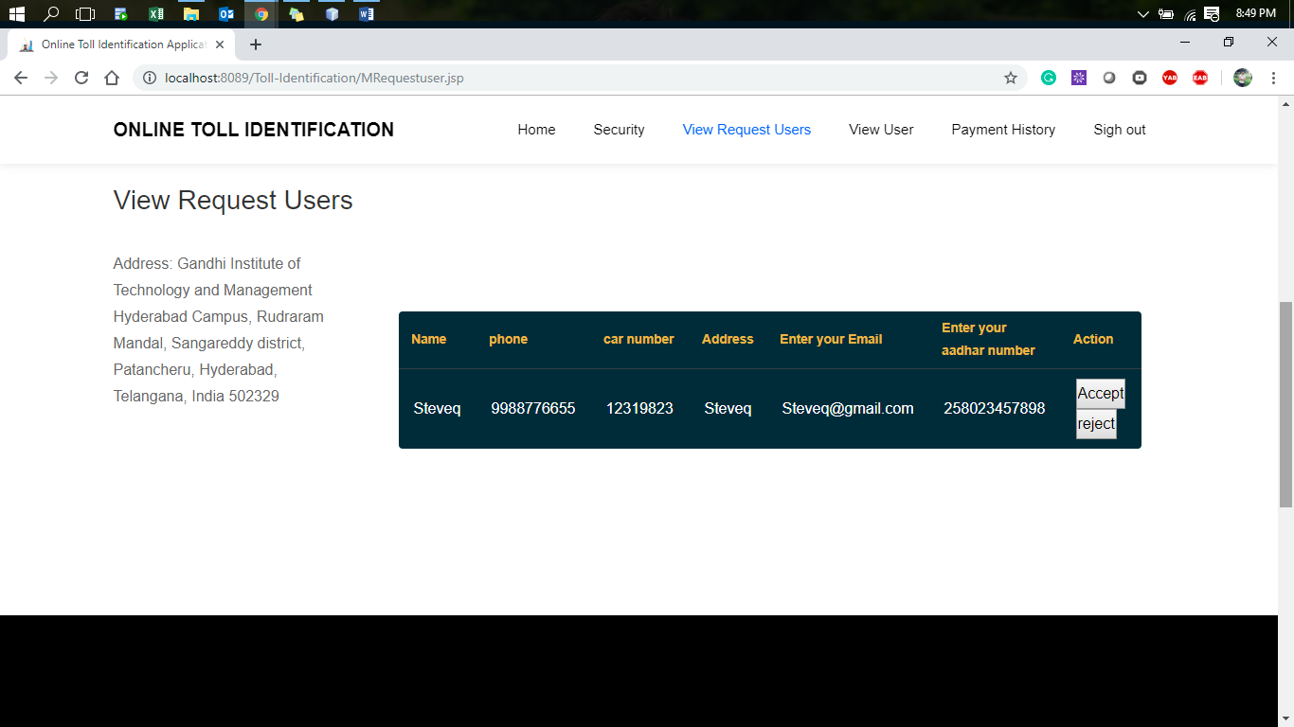

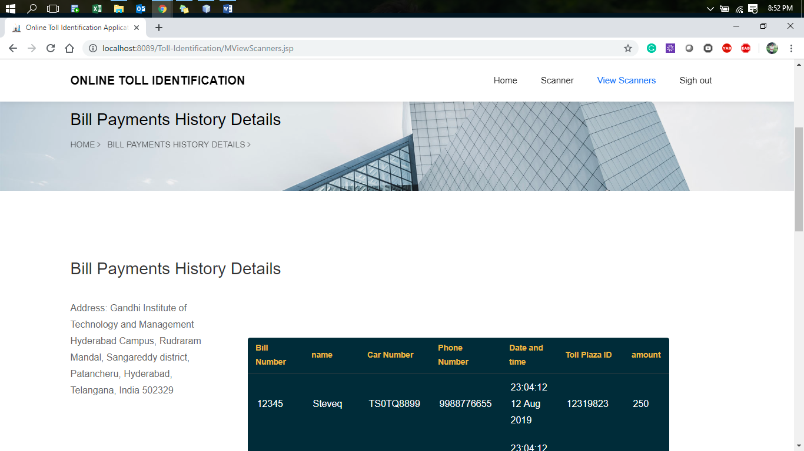

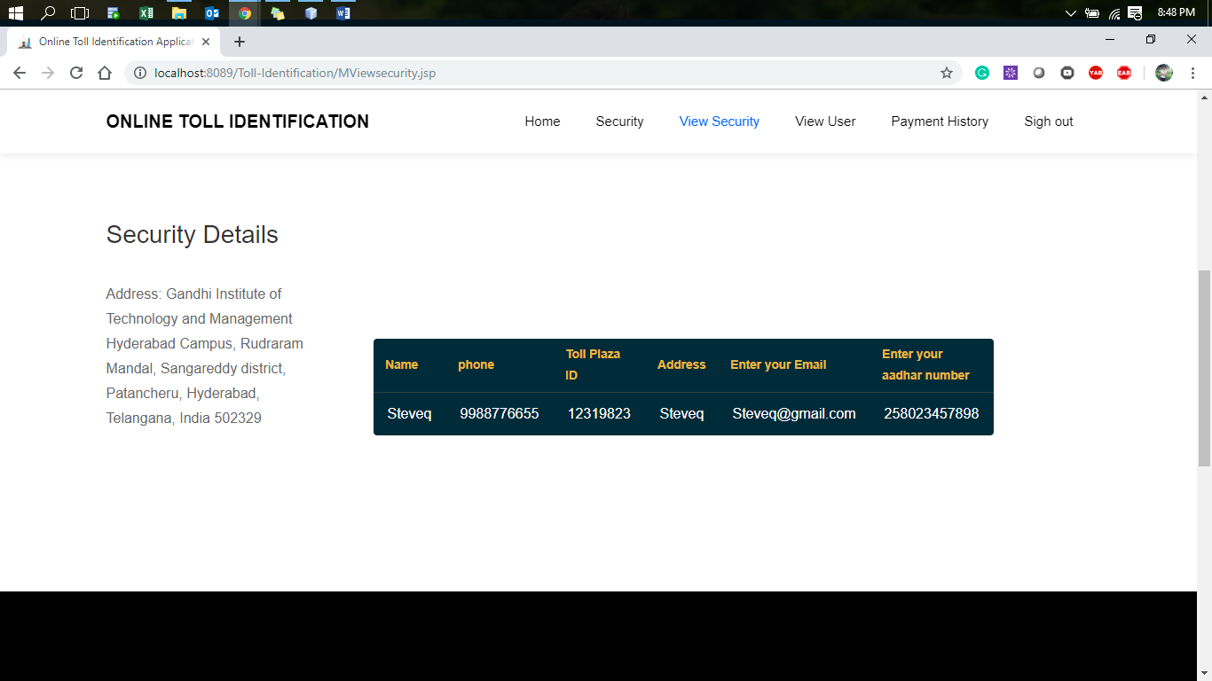

**Manager**

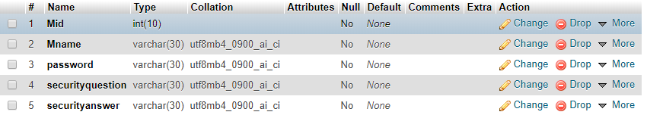

**Security**

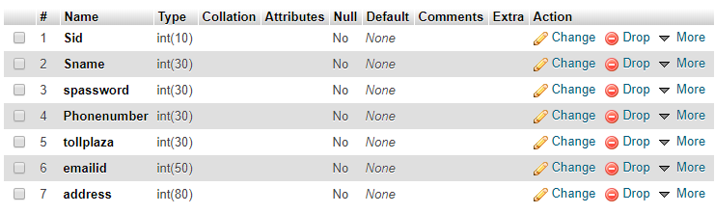

**User**

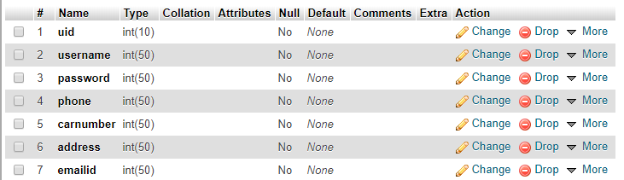

**Bill**

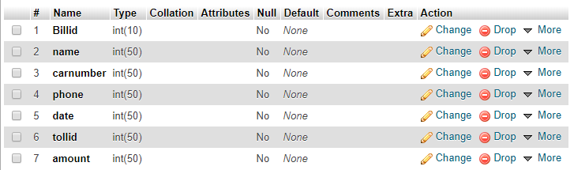

**Conclusion:**

The Online Toll Identification System streamlines the toll collection process by automating vehicle identification, payment, and record-keeping. By leveraging technologies such as RFID, ANPR (Automatic Number Plate Recognition), and digital payment gateways, the system minimizes delays, reduces human intervention, and enhances overall efficiency. This automation leads to a seamless experience for commuters, eliminating the need for cash transactions and long queues at toll booths. Additionally, it ensures accurate toll collection and reduces revenue leakage, benefiting both authorities and road users.

Beyond convenience, the system significantly improves traffic flow and reduces congestion at toll plazas. With real-time data processing, authorities can monitor vehicle movements, detect violations, and enforce toll compliance more effectively. This also enhances security by providing law enforcement agencies with data to track suspicious or unauthorized vehicles. Moreover, integrating the system with national databases ensures a more transparent and accountable toll collection mechanism, reducing fraud and unauthorized access to toll roads.

In conclusion, the Online Toll Identification System represents a significant step toward modernizing toll operations, enhancing efficiency, security, and user convenience. As technology advances, integrating AI, IoT, and blockchain could further strengthen the system’s accuracy and security. Widespread adoption of such solutions can contribute to better traffic management, reduced carbon emissions from idling vehicles, and improved infrastructure funding. Ultimately, this system fosters a smarter, more connected transportation network, paving the way for the future of road tolling.

**Future Work:**

The future development of an online toll identification system can focus on enhancing accuracy and efficiency through artificial intelligence (AI) and machine learning (ML). Implementing AI-powered image recognition and vehicle classification algorithms can improve license plate detection, even under challenging conditions such as poor lighting or bad weather. Additionally, integrating ML-based fraud detection can help prevent toll evasion by identifying suspicious patterns in vehicle data. These advancements will enable a more reliable and automated toll collection process, reducing manual interventions and errors.

Another key area of improvement is system interoperability and scalability. Future work should aim to develop a unified tolling system that seamlessly integrates with various transportation networks and digital payment platforms. This can be achieved by adopting cloud-based infrastructure and blockchain technology to enhance security, transparency, and data sharing across multiple toll agencies. Moreover, expanding the system to support multiple payment options, including e-wallets and cryptocurrencies, will enhance user convenience and encourage wider adoption.

Lastly, the system can benefit from real-time analytics and smart traffic management capabilities. By leveraging Internet of Things (IoT) devices and big data analytics, future versions of the toll identification system can provide real-time insights into traffic patterns, helping authorities manage congestion more effectively. Dynamic pricing models based on traffic conditions can be implemented to optimize toll rates, reducing peak-hour congestion. These innovations will not only improve road efficiency but also contribute to a smarter and more sustainable transportation infrastructure.

**Reference:**

1. Electronic Toll Collection (ETC) systems have revolutionized the way tolls are collected on highways and bridges, offering a more efficient and seamless experience for motorists. These systems utilize technologies such as Radio Frequency Identification (RFID), Artificial Intelligence (AI), and blockchain to automate toll payments, thereby reducing congestion and enhancing operational efficiency.
2. One notable implementation is the E-ZPass system in the United States, which employs RFID technology to allow vehicles to pass through toll points without stopping. This system has been associated with significant benefits, including reduced traffic congestion and improved air quality. Studies have shown that the adoption of E-ZPass led to a decrease in infant prematurity rates and low birth weight incidents in areas near toll plazas, attributed to reduced vehicular emissions.
3. In India, the FASTag system has been introduced to streamline toll payments. This system uses RFID tags affixed to vehicles, enabling automatic deduction of toll charges as vehicles pass through toll plazas. The implementation of FASTag has significantly reduced waiting times at toll booths and minimized fuel consumption due to decreased idling.
4. Advancements in AI have further enhanced ETC systems. Researchers have developed AI-based toll collection models that integrate RFID technology with AI algorithms to improve the accuracy and efficiency of toll operations. These systems can detect and process vehicle information in real time, reducing the likelihood of errors and enhancing the overall user experience.
5. Blockchain technology has also been explored to address security and transparency concerns in toll collection. A blockchain-based ETC system ensures secure transactions and enhances the resilience of smart contracts used in toll operations. This approach provides a decentralized platform for toll payments, reducing the risk of fraud and ensuring data integrity.
6. Another innovative approach involves the use of image processing techniques for toll collection. Systems have been developed that utilize Optical Character Recognition (OCR) to read vehicle license plates, allowing for automatic toll deduction without the need for physical tags. This method enhances the flexibility and scalability of toll systems, accommodating vehicles without pre-registered RFID tags.
7. The integration of Internet of Things (IoT) modules in toll systems has also been explored to provide real-time notifications to vehicle owners. For instance, upon toll deduction, an IoT-enabled system can send a confirmation message to the vehicle owner, enhancing transparency and user satisfaction.
8. Furthermore, the implementation of ETC systems has been linked to economic benefits, such as increased property values in areas with reduced traffic congestion. Studies have indicated that the introduction of systems like E-ZPass can lead to higher home values in nearby areas, as improved traffic flow makes these locations more desirable.

Despite the numerous advantages, privacy concerns have been raised regarding the data collected by ETC systems. The ability to track vehicle movements has led to discussions about data security and the potential misuse of personal information. Ensuring robust data protection measures is essential to address these concerns and maintain public trust in ETC systems.